Python Laboratory Submission

HARIGANESH V
E0524007
UNIT 1
import os # importing operating system packages
#Get the current directory
os.getcwd() # cwd stands for current working directory
#os.setcwd('/content/sample_data')
os.chdir('/content/sample_data')
#Variables and data type
x=5
x
5
x+2
7
str(5), str(True)
('5', 'True')
##int() #integer ()function call The data types supported to python as int (integer)
float(floating point values)
bool (boolean)
str (string)
int(1),int(5)
(1, 5)
#List
a='is'
b='nice'
my_list= ['my','list',a,b]
my_list2= [[4,5,6,7],[3,4,5,6]]
my_list
['my', 'list', 'is', 'nice']
my_list[1]
{"type":"string"}
my_list[-3]
{"type":"string"}
my_list[1:3]
['list', 'is']
Python lists are zero indexed(the first element has index 0)
x1= ['a','b','c','d','e']
x=[1,2,3]
y=[10,20,30]
z=[x,y] # to include two listed separated by comma
print (z)
u= x+y # to join two lists
print (u)
[[1, 2, 3], [10, 20, 30]]
[1, 2, 3, 10, 20, 30]
#ACCESSING THE ELEMENT OF A LIST
#select the 0th element of the list x
print (x)
x[0]
[1, 2, 3]
1
#select last element in the list
x[-1]
3
#select 1st inclusive and 3rd exclusive
x[1:3] # in the range field value is included while the last value is excluded
[2, 3]
#select 2nd to the end of x1= ['a','b','c','d','e']
x1[2:]
['c', 'd', 'e']
#select 0th to 3rd exclusive x1= ['a','b','c','d','e']
x1[:3]
['a', 'b', 'c']
#list operation : comma , ,*
y=[10,20,30]
y*2
[10, 20, 30, 10, 20, 30]
y+y
[10, 20, 30, 10, 20, 30]
#4 Aug 2025
Operators in Python
#Operators in Python
102+37 # Add 2 no. with +
102-37 #Subtract a no. with -
4*6 # Multiply 2 no. with *
22/7 #Divide a no. by another with /
22//7 #Integer divide a no. with //
22 % 7 # It is mod operator
102+37 # Add 2 no. with +
139
102-37 #Subtract a no. with -
65
4*6 # Multiply 2 no. with *
24
22/7 #Divide a no. by another with /
3.142857142857143
22//7 #Integer divide a no. with //
3
22 % 7 # It is mod operator
1
#Assignment operator
a=5 # assign a value to a
print(a)
#x[0] = 1 not possible ie. , directly do not change an item in a list
x=[10,23,45]
x[0] = 1 #change the list value at index 0
print(x)
5
[1, 23, 45]
#Relational operation in python 3==3 #test for equality with ==
3!=3 #test for inequality with !=
3>1 #test greater than with >
3>= 3 #test greater than or equal to with >=
3<4 # test less than with <
3<=4 # test less than or equal to with <=
3==3 #test for equality with ==
True
3!=3 #test for inequality with !=
False
3>1 #test greater than with >
True
3>= 3 #test greater than or equal to with >=
True
3<4 # test less than with <
True
3<=4 # test less than or equal to with <=
True
#Logical operator not (2==2) #using logical not
(1!=1) and (1<1) #using logical and
(1>=1) or (1<1) #using logical or
not (2==2) #using logical not
False
(1!=1) and (1<1) #using logical and
False
(1>=1) or (1<1) #using logical or
True
Python inbulit data structures
- LIST 2.TUPLE 3.DICTIONARY 4.SET
List: Ordered, mutable collections that can store items or different data types .They defined using square brackets []
my_list = [1, "hello", 3.14]
my_list
[1, 'hello', 3.14]
Tuples:Ordered, immutable collections, meaning their contents cannot be changed a creation. They are defined using parentheses ()
my_tuple = (10,"world",True)
my_tuple
(10, 'world', True)
Sets:Unordered collections of unique elements .They do not allow duplicate values and are defined using curly braces {} or set () constructor
my_set ={1,2,3,2} #my_set will be {1,2,3}
my_set
{1, 2, 3}
Dictionary:Unordered collections of key-value pairs,where each key must be unqiue .They are defined using curly braces {} with key-value pairs separated by colons
my_dict = {"name":"Alice","age":30}
my_dict
{'name': 'Alice', 'age': 30}
my_dict = {"name":"Hg","age":18,"grade":"Ug"}
my_dict
{'name': 'Hg', 'age': 18, 'grade': 'Ug'}
List methods
my_list = ['a','e','i','o','u']
my_list.index('o')
3
my_list.index('a')
0
my_list.count('i')
1
my_list.append('1')
my_list
['a', 'e', 'i', 'o', 'u', '1']
my_list.remove('1')
my_list
['a', 'e', 'i', 'o', 'u']
del(my_list[0:1]) #remove an item from list
my_list
['e', 'i', 'o', 'u']
my_list.reverse()
my_list
['u', 'o', 'i', 'e']
my_list.extend('$')
my_list
['u', 'o', 'i', 'e', '$']
#Extend is same as append (adding elemrnt at last of list)but it can extend a
# list with another list
my_cars = ["FORD","BMW"]
my_list.extend(my_cars)
my_list
#Differences between append() and extend()
#append can add only a single elements at the end of a list
['u', 'o', 'i', 'e', '$', 'FORD', 'BMW']
my_list.pop(-2)
my_list
['u', 'o', 'i', 'e', '$', 'BMW']
my_list.insert(0,'!')
my_list
['!', 'u', 'o', 'i', 'e', '$', 'BMW']
my_list.sort()
my_list
['!', '$', 'BMW', 'e', 'i', 'o', 'u']
#String
my_string ="Welcome to python programming"
my_string
{"type":"string"}
my_string[0]
{"type":"string"}
my_string[5:10] #print characters starting from index 0 excluding 9
{"type":"string"}
my_string.upper()
{"type":"string"}
my_string.lower()
{"type":"string"}
my_string.count('m')
3
my_string.replace('e','m')
{"type":"string"}
#11 Aug 2025
#List Processing in Python
STEPS:
1.Create a empty result list
2.Keep a total variable starting at 0
3.Loop through each number
4.Add to total , append total to result
Running sum
#Running sum Sample ip=10,20,5,1 Expected op=10,30,35,36
def runningSum(nums):
result = [] #Empty list
total = 0 #Initialist total to zero
for n in nums: #start the loop for running sum
total += n #add the value to total
result.append(total) #append the sum to result list
return(result)
print(runningSum([10,20,5,1]))
[10, 30, 35, 36]
SUM
#Sum Sample ip=10,20,5,1 Expected op=36
def Sum(a,b,c,d):
result = a+b+c+d #Empty list
print(result)
Sum(10,20,5,1)
36
Count Even number in a list
#Count Even number in a list
#Count Even number
#Sample input (3,7,2,9,5)
#Expected output : 1
def CountEven(nums):
count = 0
for n in nums:
if n%2==0:
count +=1
return count
print(CountEven([3,7,2,9,5]))
1
Reverse a list
#Reverse a list
#Reverse a list:
#Input: [1,2,3,4]
#Expected output: [4,3,2,1]
def reverseList(nums):
return nums[::-1]
print(reverseList([1,2,3,4]))
#Slicing the list
my_list = [10,5,1,0,-67]
# The list sliced from the beginning to end, taking every second element
print(my_list[::3])
[4, 3, 2, 1]
[10, 0]
Find Maximum number in the list
# #Find Maximum number in the list
# input[3,7,2,9,5]
# Expected output:9
def FindMax(nums):
max_num = nums[0]#Assign first of list as maximum
for n in nums:
if n>max_num:
max_num = n
return max_num
print(FindMax([3,7,2,9,5]))
9
Find Minimum number in the list
# #Find Minimum number in the list
# input[3,7,2,9,5]
# Expected output:2
def FindMin(nums):
min_num = nums[0]#Assign first of list as minimum
for n in nums:
if n<min_num:
min_num = n
return min_num
print(FindMin([3,7,2,9,5]))
2
Merge 2 sorted list
#Merge 2 sorted list
#Input: [1,3,5],[2,4,6]
#Output: [1,2,3,4,5,6]
def mergeList(list1,list2):
return sorted(list1 + list2)
print(mergeList([1,3,5],[2,4,6]))
[1, 2, 3, 4, 5, 6]
Square of a sorted list
#Square of a sorted list
def SortedSquare(nums):
return sorted([x**2 for x in nums])
# List comprehension: Defines a list based on iteration that is
#[x**2 for x in nums]
#is defined to find square of elements in the sorted list
print(SortedSquare([-4,-1,0,3,-50]))
[0, 1, 9, 16, 2500]
def MaxDeposit(accounts):
return max(sum(cust) for cust in accounts)
print(MaxDeposit([[100,52],[3,60]]))
152
Find 2 indices where numbers add up to the target
# Find 2 indices where numbers add up to the target
#Input: [2,7,11,15] target:26
#Expected Output: [2,3]
def twoSum(nums,target):
#define a dictionary , a key value pair
seen ={}
for i,n in enumerate(nums):
diff = target - n
if diff in seen:
return [seen[diff],i]
seen[n] = i
print(seen)
print(twoSum([2,7,11,15],26))
{2: 0}
{2: 0, 7: 1}
{2: 0, 7: 1, 11: 2}
[2, 3]
#Sep 1 2025
#CREATE (Add new key value pair)
student={}
student["name"]="Hg"
student["age"]=18
print(student)
{'name': 'Hg', 'age': 18}
Read
print(student["name"])
print(student.get("age"))
Hg
18
print(student.get("grade","not available"))
not available
Update
student["name"]="Bob"
student["age"]=20
student["grade"]="A"
print(student)
{'age': 20, 'grade': 'A', 'name': 'Bob'}
Delete
del student["grade"]#delete removes key and value
print(student)
{'age': 20, 'name': 'Bob'}
Remove
removed = student.pop("name")#pop will delete the key,but value is present Still cannot access the value
print(student)
print(removed)
{'age': 20}
Bob
C(Create) -> dict[key]=value
R(Read) -> dict[key]<dict.get(key)
U(Update) -> dict[key]=new_value (or) ordict.update({})
D(Delete) -> del dict[key].pop(key).clear()
#NESTED DICTIONARY
#Create a nested dictionary with student data
student={
"Alice":{"Math":80,"Science":90,"English":95},
"Hg":{"Math":95,"Science":70,"English":67},
"Gopi":{"Math":75,"Science":50,"English":87},
"Lazar":{"Math":45,"Science":100,"English":97},
"Srinivasan":{"Math":75,"Science":90,"English":37},
"Jayabalan":{"Math":55,"Science":90,"English":77}
}
print(student)
{'Alice': {'Math': 80, 'Science': 90, 'English': 95}, 'Hg': {'Math': 95, 'Science': 70, 'English': 67}, 'Gopi': {'Math': 75, 'Science': 50, 'English': 87}, 'Lazar': {'Math': 45, 'Science': 100, 'English': 97}, 'Srinivasan': {'Math': 75, 'Science': 90, 'English': 37}, 'Jayabalan': {'Math': 55, 'Science': 90, 'English': 77}}
import pandas as pd #pandas are library for data manipulation
data = pd.DataFrame(student)#pass thedictonary to DataFrame
data
{"summary":"{\n \"name\": \"data\",\n \"rows\": 3,\n \"fields\": [\n {\n \"column\": \"Alice\",\n \"properties\": {\n \"dtype\": \"number\",\n \"std\": 7,\n \"min\": 80,\n \"max\": 95,\n \"num_unique_values\": 3,\n \"samples\": [\n 80,\n 90,\n 95\n ],\n \"semantic_type\": \"\",\n \"description\": \"\"\n }\n },\n {\n \"column\": \"Hg\",\n \"properties\": {\n \"dtype\": \"number\",\n \"std\": 15,\n \"min\": 67,\n \"max\": 95,\n \"num_unique_values\": 3,\n \"samples\": [\n 95,\n 70,\n 67\n ],\n \"semantic_type\": \"\",\n \"description\": \"\"\n }\n },\n {\n \"column\": \"Gopi\",\n \"properties\": {\n \"dtype\": \"number\",\n \"std\": 18,\n \"min\": 50,\n \"max\": 87,\n \"num_unique_values\": 3,\n \"samples\": [\n 75,\n 50,\n 87\n ],\n \"semantic_type\": \"\",\n \"description\": \"\"\n }\n },\n {\n \"column\": \"Lazar\",\n \"properties\": {\n \"dtype\": \"number\",\n \"std\": 30,\n \"min\": 45,\n \"max\": 100,\n \"num_unique_values\": 3,\n \"samples\": [\n 45,\n 100,\n 97\n ],\n \"semantic_type\": \"\",\n \"description\": \"\"\n }\n },\n {\n \"column\": \"Srinivasan\",\n \"properties\": {\n \"dtype\": \"number\",\n \"std\": 27,\n \"min\": 37,\n \"max\": 90,\n \"num_unique_values\": 3,\n \"samples\": [\n 75,\n 90,\n 37\n ],\n \"semantic_type\": \"\",\n \"description\": \"\"\n }\n },\n {\n \"column\": \"Jayabalan\",\n \"properties\": {\n \"dtype\": \"number\",\n \"std\": 17,\n \"min\": 55,\n \"max\": 90,\n \"num_unique_values\": 3,\n \"samples\": [\n 55,\n 90,\n 77\n ],\n \"semantic_type\": \"\",\n \"description\": \"\"\n }\n }\n ]\n}","type":"dataframe","variable_name":"data"}
Data in row wise
data = pd.DataFrame(student).T #T=Transpose to get the student as row
data
{"summary":"{\n \"name\": \"data\",\n \"rows\": 6,\n \"fields\": [\n {\n \"column\": \"Math\",\n \"properties\": {\n \"dtype\": \"number\",\n \"std\": 18,\n \"min\": 45,\n \"max\": 95,\n \"num_unique_values\": 5,\n \"samples\": [\n 95,\n 55,\n 75\n ],\n \"semantic_type\": \"\",\n \"description\": \"\"\n }\n },\n {\n \"column\": \"Science\",\n \"properties\": {\n \"dtype\": \"number\",\n \"std\": 18,\n \"min\": 50,\n \"max\": 100,\n \"num_unique_values\": 4,\n \"samples\": [\n 70,\n 100,\n 90\n ],\n \"semantic_type\": \"\",\n \"description\": \"\"\n }\n },\n {\n \"column\": \"English\",\n \"properties\": {\n \"dtype\": \"number\",\n \"std\": 22,\n \"min\": 37,\n \"max\": 97,\n \"num_unique_values\": 6,\n \"samples\": [\n 95,\n 67,\n 77\n ],\n \"semantic_type\": \"\",\n \"description\": \"\"\n }\n }\n ]\n}","type":"dataframe","variable_name":"data"}
Average
data["Average"]=data.mean(axis=1)
#axis=1 denotes row wise access to data frame
data
{"summary":"{\n \"name\": \"data\",\n \"rows\": 6,\n \"fields\": [\n {\n \"column\": \"Math\",\n \"properties\": {\n \"dtype\": \"number\",\n \"std\": 18,\n \"min\": 45,\n \"max\": 95,\n \"num_unique_values\": 5,\n \"samples\": [\n 95,\n 55,\n 75\n ],\n \"semantic_type\": \"\",\n \"description\": \"\"\n }\n },\n {\n \"column\": \"Science\",\n \"properties\": {\n \"dtype\": \"number\",\n \"std\": 18,\n \"min\": 50,\n \"max\": 100,\n \"num_unique_values\": 4,\n \"samples\": [\n 70,\n 100,\n 90\n ],\n \"semantic_type\": \"\",\n \"description\": \"\"\n }\n },\n {\n \"column\": \"English\",\n \"properties\": {\n \"dtype\": \"number\",\n \"std\": 22,\n \"min\": 37,\n \"max\": 97,\n \"num_unique_values\": 6,\n \"samples\": [\n 95,\n 67,\n 77\n ],\n \"semantic_type\": \"\",\n \"description\": \"\"\n }\n },\n {\n \"column\": \"Average\",\n \"properties\": {\n \"dtype\": \"number\",\n \"std\": 7.514184118250161,\n \"min\": 67.33333333333333,\n \"max\": 88.33333333333333,\n \"num_unique_values\": 6,\n \"samples\": [\n 88.33333333333333,\n 77.33333333333333,\n 74.0\n ],\n \"semantic_type\": \"\",\n \"description\": \"\"\n }\n }\n ]\n}","type":"dataframe","variable_name":"data"}
#data["Average"]=data.mean(axis=0)
##axis=0 denotes col wise access to data frame
#data
##The result is not a number(NAN) because there is no variables to store the average of number

UNIT 5

import matplotlib.pyplot as plt
#Bar chart for student Average performance
plt.figure(figsize=(8,5))
data["Average"].plot(kind="bar",color="skyblue",edgecolor="black")
plt.title("Average Mark of Students")
plt.xlabel("Students")
plt.ylabel("Average Marks")
plt.show()
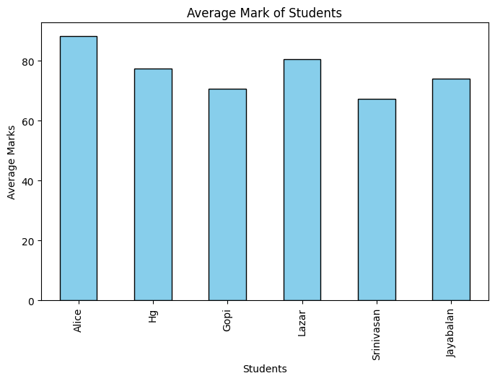
plt.figure(figsize=(8,5))
#data["Average"].plot(kind="bar",color="skyblue",edgecolor="black")
for subject in ["Math","Science","English"]:
plt.plot(data.index, data[subject], marker='o',label=subject)
plt.title("Subject wise performance")
plt.xlabel("Students")
plt.ylabel("Marks")
plt.show()
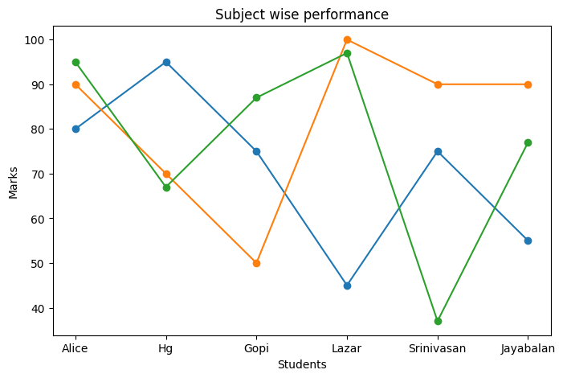
plt.figure(figsize=(8,5))
data[["Math","Science","English"]].plot(kind="box")
plt.title("Marks Distribution by Students")
plt.xlabel("Students")
plt.ylabel("Marks")
plt.show()
<Figure size 800x500 with 0 Axes>
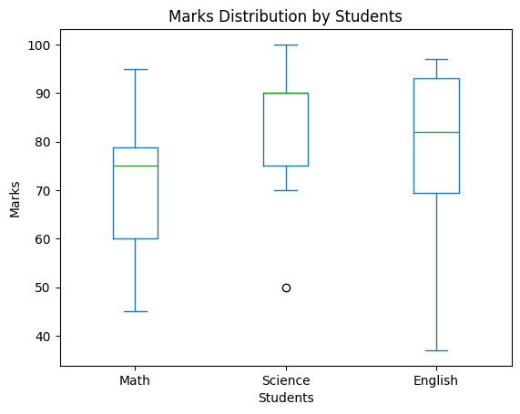
#Conclusion
- The student details are created using nested dictionary
- The Nested Dictionary is converted to pandas dataframe
- The data analytics are performed and visualized using matplotlib
#8 SEP 2025
import pandas as pd
import seaborn as sns
import matplotlib.pyplot as plt
data = {
"Student" : ["Gopi","Lazar","Srinivasan","Jayabalan","Vajjiravelu"],
"Fee Paid" : [1000,2000,3000,4000,5000]
}
df = pd.DataFrame(data)
sns.barplot(x="Student",y="Fee Paid",data=df)
plt.show()
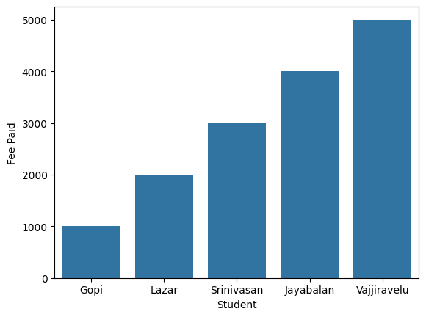
import matplotlib.pyplot as plt
import numpy as np
from scipy.stats import gaussian_kde
fees = [48000,43200,45600,38400,48000]
density = gaussian_kde(fees)
xs = np.linspace(min(fees),max(fees),200)
plt.plot(xs, density(xs))
plt.show()
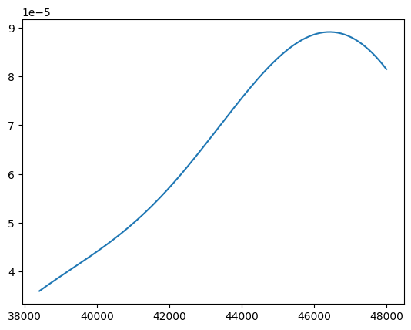
Fees= [48000,43200,45600,38400,48000]
plt.boxplot(Fees)
plt.show()
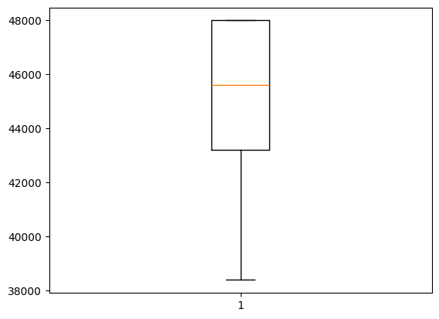
Fees=[48000,43200,45600,38400,48000]
plt.hist(Fees)
plt.show()
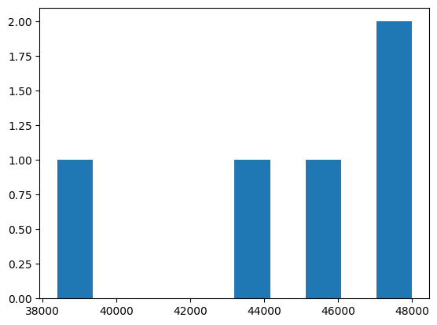
#15 Sep 2025
import matplotlib.pyplot as plt
students = ["Gopi","Lazar","Srinivasan","Jayabalan","Vajjiravelu"]
fees = [48000, 43200, 45600, 38400, 48000]
plt.barh(students, fees, color="lightgreen")
plt.title("Fee Paid by students")
plt.xlabel("Fees")
plt.ylabel("Students")
plt.show()
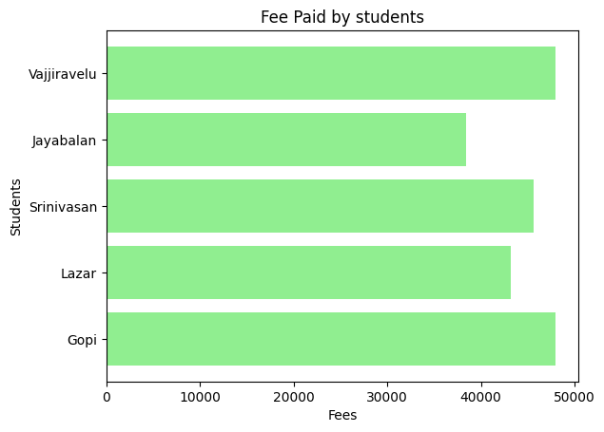
fees = [50000, 43200, 45600, 38400, 48000]
plt.pie(fees, labels=Students, autopct="%2.1f%%")
plt.show()
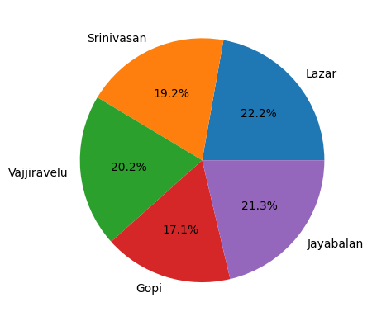
import plotly.express as px
import pandas as pd
#Sample data
data={
"Students":["Aarav","Divya","Riyas","Anu","Arjun"],
"Fees Paid":[18000,43200,56000,38400,50000]
}
df=pd.DataFrame(data)
#Create bar chart
fig=px.bar(df,x="Students",y="Fees Paid",title="Fee Paid by Students")
#Save to HTML file (opens directly in browser, no server)
fig.write_html("fee_chart.html", auto_open=True)
fig.show()

UNIT 2
class Animal:
def sound(self):
print("Animal makes sound")
animal = Animal()
animal.sound()
Animal makes sound
#Sep 22 2025
#Data Abstraction
class CoffeeMachine:
def __init__(self):
self.water = 100
def make_coffee(self):
if self.water >= 10:
self.water -= 10
print("Coffee is ready")
else:
print("not enough water to make coffee")
machine=CoffeeMachine()
machine.make_coffee()
Coffee is ready
#Encapsulation
class BankAccount:
def _init_(self, amount):
self.__balance = 0
def set_balance(self, amount):
self.__balance = amount
def get_balance(self):
return self.__balance
account = BankAccount()
account.set_balance(1000)
print("Account balance:", account.get_balance())
Account balance: 1000
#Inheritance
Multi level
class Animal:
def move(self):
print("Animal moves")
class Bird(Animal):
def fly(self):
print("Bird flies")
class Parrot(Bird):
def talk(self):
print("Parrot talks")
parrot = Parrot()
parrot.move()
parrot.fly()
parrot.talk()
Animal moves
Bird flies
Parrot talks
Single
class Father:
def speak(self):
print("Father speaks")
class Son(Father):
def recieve(self):
print("Son recieves")
son = Son()
son.speak()
son.recieve()
Father speaks
Son recieves
Polymorphism
class cat:
def sound(self):
print("meow")
class dog:
def sound(self):
print("bark")
for animal in (cat(), dog()):
animal.sound()
meow
bark

Unit 3
#Exp 12
#Read the file
file_path = r"/content/HELLO WORLD.txt"
print("=== Example 1: Read Entire File ===")
with open(file_path, 'r') as file:
content = file.read()
print(content)
=== Example 1: Read Entire File ===
HELLOWORLD
HG HERE
PYTHON LABORATORY
UNIT 3
#Read line by line
file_path = r"/content/HELLO WORLD.txt"
print("=== Example 1: Read Line by Line ===")
with open(file_path, 'r') as file:
for line in file:
print("line from file", line)
=== Example 1: Read Line by Line ===
line from file HELLOWORLD
line from file HG HERE
line from file PYTHON LABORATORY
line from file UNIT 3
#Result 1st 10 characters
file_path = r"/content/HELLO WORLD.txt"
print("\n=== Read Specific Parts ===")
with open(file_path, 'r') as file:
first_10_chars = file.read(10)
print("First 10 characters:", first_10_chars)
first_line = file.readline()
print("line from file", first_line)
=== Read Specific Parts ===
First 10 characters: HELLOWORLD
line from file
#Exp 13
#Adding new line
file_path = r"/content/HELLO WORLD.txt"
with open(file_path, 'a') as file:
file.write("This line is appended later.\n")
print("New line appended Successfully")
New line appended Successfully
#Adding multiple line
file_path = r"/content/HELLO WORLD.txt"
lines =[
"Line 1:Python is great.\n",
"Line 2:Python is easy.\n",
"Line 3:Python is powerful.\n"
]
with open(file_path, 'a') as file:
file.writelines(lines)
print("New lines appended successfully!")
New lines appended successfully!
Oct 6 2025
#Exp 14
File tell
with open("/content/HELLO WORLD.txt", "r") as f:
print(f.tell())
data = f.read(6)
print(data)
print(f.tell())
0
HELLOW
6
Seek
with open("/content/HELLO WORLD.txt", "r") as f:
print(f.tell())
data = f.read(6)
print(data)
f.seek(0)
0
HELLOW
#Exp 15
Readable & Writable
f = open("/content/HELLO WORLD.txt", "r")
print(f.readable())
print(f.writable())
print(f.seekable())
True
False
True
#Exp 16
Renamed & deleted
import os
with open("/content/HELLO WORLD.txt", "w") as f:
f.write("Hello World")
os.rename("/content/HELLO WORLD.txt", "/content/new_BOSS.txt")
print("File renamed successfully!")
os.remove("/content/new_BOSS.txt")
print("File deleted successfully!")
File renamed successfully!
File deleted successfully!
#Exp 17
Rename & deleted folder
import os
os.mkdir("/content/new_folder")
print("Folder created successfully!")
print(os.listdir("."))
os.rmdir("/content/new_folder")
print("Folder deleted successfully!")
Folder created successfully!
['.config', 'new_folder', 'sample_data']
Folder deleted successfully!

UNIT 4
#Types of Exception errors:
EXP-18 Zero division error
try:
print(10/0)
except ZeroDivisionError:
print("X ZeroDivisionError: You cannot divide zero.\n")
X ZeroDivisionError: You cannot divide zero.
EXP-19
ValueError
try:
num=int("abc")
except ValueError:
print("X ValueError: Cannot convert string to integer.\n")
X ValueError: Cannot convert string to integer.
TypeError
try:
result="2"+2
except TypeError:
print("X TypeError:You tried to add string and integer.\n")
X TypeError:You tried to add string and integer.
IndexError
try:
list1=[1,2,3]
print(list1[5])
except IndexError:
print("X IndexError: List index out of range.\n")
X IndexError: List index out of range.
Keyerror
try:
my_dict={"name":'HG'}
print(my_dict['age'])
except KeyError:
print("X KeyError: Dictionary key not found.\n")
X KeyError: Dictionary key not found.
FileNotFound Error
try:
open("missing.txt")
except FileNotFoundError:
print("X FileNotFoundError: The file does not exist.\n")
X FileNotFoundError: The file does not exist.
NameError
try:
print(undefined_variable)
except NameError:
print("X NameError : Variable is not defined.\n")
X NameError : Variable is not defined.
EXP-20
Exception Handling
try:
num1 = int(input("Enter a number: "))
num2 = int(input("Enter another number: "))
result = num1 / num2
except ZeroDivisionError:
print("error: you cannot divide by zero")
except ValueError:
print("error: please enter number only")
else:
print("result:",result)
finally:
print("program execution completed")
Enter a number: 20
Enter another number: 2
result: 10.0
program execution completed

